

A PROJECT REPORT ON
“ECOVISION – AN AI POWERED WASTE DETECTION SYSTEM”
Submitted in partial fulfillment of the requirements for the award of degree of

BACHELOR OF ENGINEERING

IN
AEC VERTICAL LEVEL - 3

Submitted By

ANANYA KAMATH S [1MJ23IS006]
HEMA SATHVIKA V [1MJ23IS027]
RISHIKESH TALE [1MJ23IS064]
POOJA R [1MJ23CH009]

Under the Guidance of
Prof. Shashi Kumar P M
Dept. Of Civil Engineering

MVJ COLLEGE OF ENGINEERING
BANGALORE - 67
ACADEMIC YEAR 2025 - 2026



MVJ COLLEGE OF ENGINEERING
Near ITPB, Whitefield, Bengaluru– 560067

CERTIFICATE
This is to certify that the Project Phase work titled “Eco Vision – An AI Powered Waste Detection System” is carried out by us who are Bonafide students of MVJ College of Engineering, Bengaluru, in partial fulfillment for the award of Degree of Bachelor of Engineering in Chemical Engineering of the Visvesvaraya Technological University, Belagavi during the year 2025 - 2026. It is certified that all corrections/suggestions indicated for the Internal Assessment have been incorporated in the major project report deposited in the departmental library. The Project report has been approved as it satisfies the academic requirements in respect of AEC Vertical Level - 3 project work prescribed by the institution for the said Degree.

Signature of AEC Coordinator Signature of HOD
Prof .SHASHIKUMAR P M Prof. VIDHYA A CARMEL

EXTERNAL EXAMINERS
Name of Examiners Signature with date

2.

ABSTRACT

Waste management has become a major challenge due to increasing waste generation and improper segregation practices. Manual sorting of waste is time-consuming, labor-intensive, and prone to errors, leading to reduced recycling efficiency and increased environmental pollution.
This project proposes an AI-based smart waste detection system that uses Computer Vision and Deep Learning techniques for automated waste classification. The system processes images of mixed waste using an object detection model such as YOLO (You Only Look Once) to identify and classify items as recyclable or non-recyclable in real time.
The output is displayed using colored bounding boxes, where green indicates recyclable items and red indicates non-recyclable items, making the results easy to understand. The system aims to improve waste segregation accuracy, reduce human effort, and support sustainable waste management practices.

TABLE OF CONTENTS

ACKNOWLEDGEMENT I
ABSTRACT II
TABLE OF CONTENT III
TABLE OF FIGURES VI
CHAPTER 1 INTRODUCTION 05
CHAPTER 2 LITERATURE SURVEY 07
CHAPTER 3 MATERIALS AND METHODOLOGY 10
CHAPTER 4 RESULTS 13
CHAPTER 5 CONCLUSION 17
REFERENCES 19

LIST OF FIGURES

FIGURE NO. | FIGURE NAME | PAGE NO.
3.1 | System Architecture of Eco Vision AI-Based Waste Detection System | 11
4.1 | Detection of Non – Recyclable Waste Using Eco vision System | 14
4.2 | Input Image Upload Interface of Eco vision System | 15
4.3 | Detection of Recyclable Waste Using Eco vision System | 15
4.4 | Output Detection of Waste Classification Using AI Model | 16

CHAPTER 1
INTRODUCTION

Waste management has become a significant global concern due to rapid industrialization, urbanization, and population growth. The increasing consumption of resources has led to a substantial rise in the amount of waste generated daily. Improper handling and disposal of this waste can lead to serious environmental issues such as land pollution, water contamination, and health hazards. Therefore, efficient waste management practices are essential for maintaining a clean and sustainable environment.
One of the most important steps in waste management is the proper segregation of waste at the source. Waste is generally classified into categories such as recyclable and non-recyclable materials. Recyclable waste includes materials like plastic, glass, and metal, which can be processed and reused, whereas non-recyclable waste includes organic waste and contaminated materials that cannot be easily reused. However, in many real-world scenarios, waste is not segregated properly, leading to mixing of different types of waste.
Traditional waste segregation methods mainly rely on manual sorting by workers. This process is not only time-consuming but also labor-intensive and prone to human error. Workers are exposed to unhealthy and hazardous conditions while handling mixed waste. Moreover, manual sorting lacks consistency and accuracy, which results in contamination of recyclable materials. This reduces the overall efficiency of recycling processes and increases the amount of waste sent to landfills.
Existing automated systems, such as those based on sensors or RFID technologies, have been developed to improve waste management. However, these systems have limitations in accurately identifying different types of waste, especially when visual characteristics are involved. They are also less flexible and may require hardware modifications to adapt to new types of waste materials.
With the advancement of Artificial Intelligence, new opportunities have emerged to improve waste management systems. Computer Vision enables machines to interpret and analyze visual data, while Deep Learning models such as Convolutional Neural Networks (CNNs) can learn complex patterns from images. These technologies make it possible to develop intelligent systems that can automatically detect and classify waste materials with high accuracy.
In this project, an AI-based smart waste detection system is proposed to address the limitations of traditional methods. The system uses an object detection model such as YOLO (You Only Look Once) to analyze images of mixed waste and identify individual items present in the image. Based on the classification, recyclable items are highlighted with green bounding boxes, while non-recyclable items are marked with red bounding boxes, providing a clear and intuitive output.
The proposed system focuses on improving the efficiency, accuracy, and speed of waste segregation. It also reduces the need for manual intervention and supports better recycling practices. Furthermore, the system can be implemented using edge computing devices, enabling real-time processing and making it suitable for integration into smart bins and modern waste management infrastructure.
Overall, this project aims to contribute to cleaner environments and sustainable development by utilizing advanced technologies in waste management. By automating the process of waste classification, the system helps in reducing environmental pollution and promotes responsible waste disposal practices.

1.2 Objectives

- Automated Segregation:
To develop an AI-based system for automatic waste sorting using object detection models.
- Real time Classification:
To identify and classify waste items as recyclable or non-recyclable instantly, improving the efficiency of recycling processes.
- Visual Feedback system:
To generate output images with colored bounding boxes (green for recyclable and red for non-recyclable) for easy understanding and verification.
- Edge computing Implementation:
To deploy the system on edge devices such as Raspberry Pi or NVIDIA Jetson to ensure real-time performance with reduced latency.
- Reusabilityscoring:
To assign a numerical score based on the condition and type of waste, helping in decision-making for reuse or disposal.

CHAPTER 2
LITERATURE SURVEY

2.1 A. Kumar et al. (2020), “Waste Classification Using Convolutional Neural Networks”
A. Kumar et al. proposed a waste classification system based on Convolutional Neural Networks (CNN) to categorize waste materials such as plastic, paper, and metal. The model was trained on a labeled dataset of waste images and demonstrated good accuracy in classification tasks. The study highlighted the effectiveness of deep learning techniques in improving waste segregation efficiency compared to traditional methods.
However, the system primarily focuses on image classification and is limited in detecting multiple objects within a single image. It also lacks real-time detection capability, which restricts its application in dynamic environments.

2.2 S. Sharma et al. (2019), “IoT-Based Smart Waste Management System”
S. Sharma et al. developed a smart waste management system using Internet of Things (IoT) technology. The system uses sensors to monitor the fill level of waste bins and sends alerts when the bins are full, thereby improving waste collection efficiency and preventing overflow.
Despite its effectiveness in monitoring, the system does not perform waste classification. It cannot differentiate between recyclable and non-recyclable waste, which limits its contribution to improving recycling processes.

2.3 R. Gupta et al. (2021), “Waste Segregation Using Image Processing Techniques”
R. Gupta et al. proposed a method for waste segregation using traditional image processing techniques such as color detection, edge detection, and texture analysis. The system attempts to classify waste based on visual features without using advanced machine learning models.
The major limitation of this approach is its sensitivity to environmental conditions such as lighting and background variations, which reduces accuracy. It is not robust enough for real-world applications involving complex waste scenarios.

2.4 J. Redmon et al. (2016), “You Only Look Once: Unified Real-Time Object Detection”
J. Redmon et al. introduced the YOLO algorithm, a real-time object detection system that can detect multiple objects in a single image with high speed and accuracy. The model divides the image into grids and predicts bounding boxes along with class probabilities, making it highly efficient for real-time applications.
However, YOLO requires a large and well-annotated dataset for effective training. Its performance may also vary depending on the complexity of the dataset and environmental conditions.

2.5 M. Patel et al. (2022), “Automated Waste Segregation Using Deep Learning Techniques”
M. Patel et al. proposed an automated waste segregation system that integrates deep learning algorithms with mechanical components for physical sorting. The system aims to reduce human intervention and improve classification accuracy.
The limitation of this system is the high implementation cost due to the inclusion of hardware components. Additionally, it focuses more on mechanical sorting rather than lightweight real-time detection models.

2.6 K. Singh et al. (2020), “AI-Based Smart Bin for Waste Detection and Classification”
K. Singh et al. developed a smart bin system integrated with Artificial Intelligence to detect and classify waste items. The system uses image processing techniques to identify waste types and improve waste management in urban areas.
However, the system has limitations in scalability and adaptability. It does not effectively handle complex waste categories and lacks advanced features such as reusability scoring and efficient edge deployment.

2.7 Summary of Literature Survey

From the above studies, it is observed that various approaches have been developed for waste management using Artificial Intelligence, Internet of Things, and image processing techniques. While some systems focus on waste classification, others emphasize monitoring and collection efficiency. However, very few systems provide a complete solution that integrates real-time detection, classification, and intelligent decision-making.

Most existing systems face challenges such as lack of real-time performance, dependency on controlled environments, high implementation costs, and limited scalability. Additionally, advanced features like reusability analysis and efficient deployment on edge devices are often missing.

Therefore, there is a need for an integrated and efficient system that overcomes these limitations. The proposed project addresses these issues by using an object detection model like YOLO for real-time waste detection, along with features such as reusability scoring and edge computing for faster and scalable implementation.

CHAPTER 3

MATERIALS AND METHODOLOGY

3.1 Materials Required

The proposed system requires both hardware and software components for implementation.

Software:

Python

OpenCV

TensorFlow / PyTorch

YOLO (You Only Look Once model)

Web Interface

3.2 System Architecture

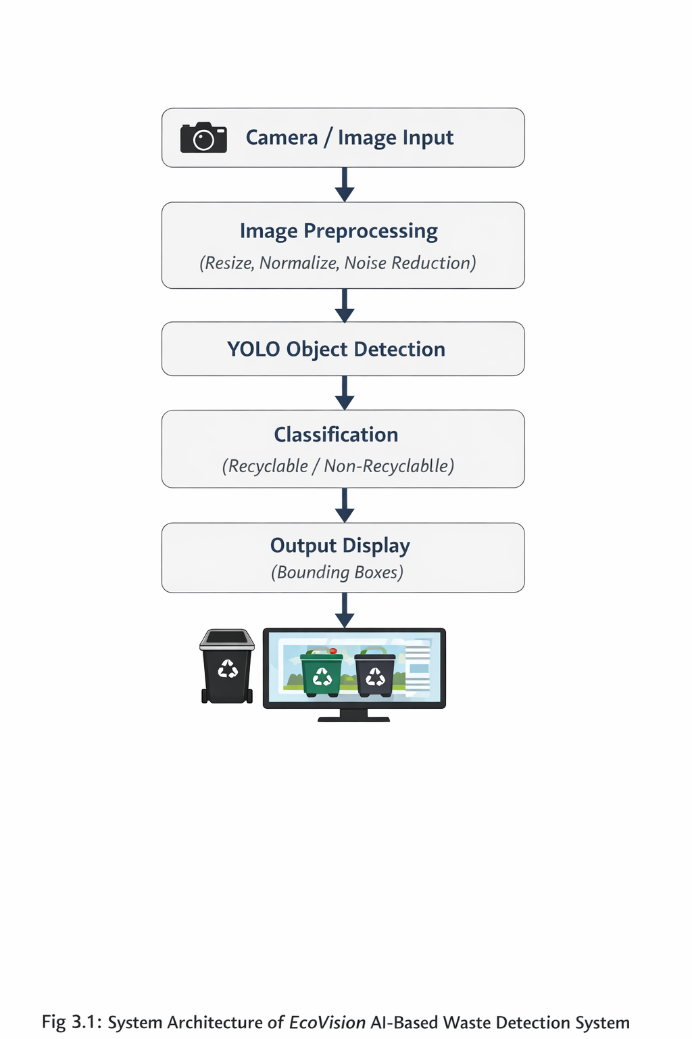

Fig 3.1: System Architecture of Eco Vision AI-Based Waste Detection System

3.3 Methodology

Step 1: Image Acquisition

The system captures images of waste using a camera. These images may contain multiple waste items in different orientations and lighting conditions.

Step 2: Data Preprocessing

The captured image is preprocessed to improve quality. This includes resizing, normalization, and noise reduction to ensure better model performance.

Step 3: Object Detection using YOLO

The preprocessed image is passed to the YOLO model, which detects multiple objects in a single image and generates bounding boxes around them. YOLO is chosen because of its ability to perform real-time detection efficiently.

Step 4: Classification

Each detected object is classified into:

Recyclable

Non-recyclable

This classification is based on trained data and visual features of the objects.

Step 5: Output Generation

The system displays results using:

🟢 Green bounding boxes → Recyclable

🔴 Red bounding boxes → non-recyclable

Step 6: Reusability scoring

The system can assign a score based on:

Material type

Condition of waste

This helps in deciding whether an item can be reused or discarded.

Step 7: Deployment

The system can be deployed on edge devices like Raspberry Pi for real-time performance, reducing dependency on cloud systems.

CHAPTER 4

RESULTS AND DISCUSSION

4.1 Results

The proposed AI-based waste detection system was tested using various input images containing

different types of waste materials such as plastic bottles, paper, metal cans, and mixed waste

items. The system successfully processed the input images and detected multiple objects present

in the scene using the YOLO object detection model.

Each detected object was classified into either recyclable or non-recyclable categories. The

results were displayed using colored bounding boxes, where green boxes represent recyclable items and red boxes represent non-recyclable items. This visual representation makes it easy to understand the classification output.

The system demonstrated the ability to identify multiple waste items in a single image and

classify them accurately in real time. The detection results confirm that the model is capable of

handling mixed waste scenarios effectively.



Fig 4.1: Detection of Non-Recyclable Waste Using Eco vision System

The system classifies the waste as non-recyclable, ensuring proper segregation. This helps in

preventing contamination of recyclable materials.

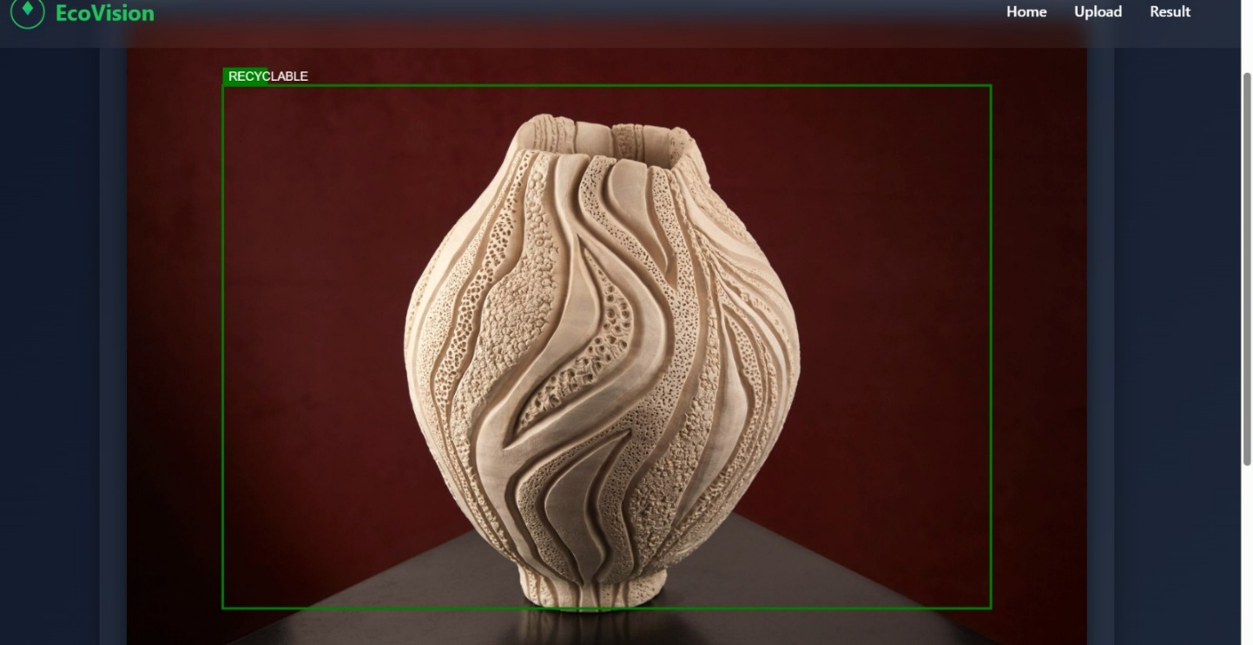

Fig 4.2: Input Image Upload Interface of Eco vision System

The system identifies the waste as recyclable with a high confidence score. This indicates

accurate detection of materials that can be reused or processed.

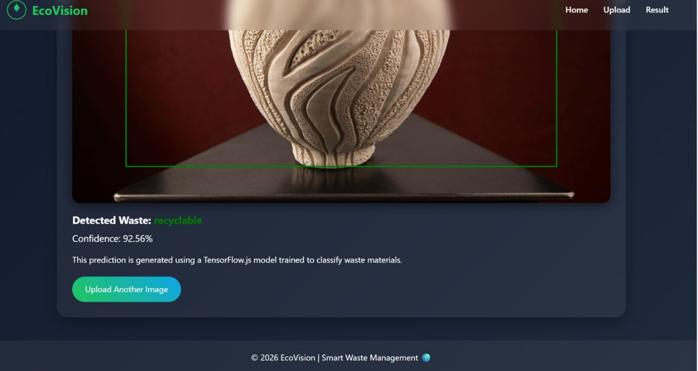

Fig 4.3: Detection of Recyclable Waste Using Eco vision System

The system processes the input image and provides classification results in real time. This

demonstrates the capability of the model to handle different types of waste effectively.

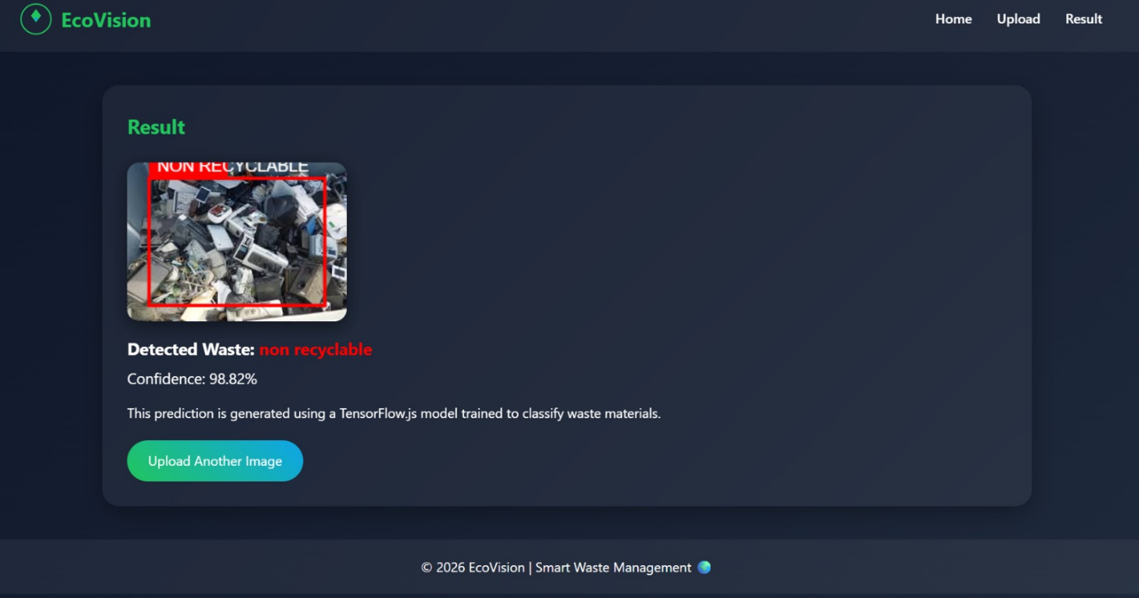

Fig 4.4 Output Detection of Waste Classification Using AI Model

The input image containing mixed waste is provided to the system for analysis. This image

serves as the initial data for detection and classification.

4.2 Discussion

From the obtained results, it can be observed that the system performs efficient detection and

classification of waste items using deep learning techniques. The YOLO model enables real-time

object detection, which is suitable for practical applications such as smart bins and automated

waste segregation systems.

The system accurately identifies common recyclable materials such as plastic bottles, metal cans,

and paper, while also distinguishing non-recyclable waste. The use of colored bounding boxes

improves the clarity of the output and makes it user-friendly.

However, the performance of the system may vary under certain conditions. Factors such as poor

lighting, overlapping objects, and complex backgrounds can affect detection accuracy. In some

cases, objects with similar visual features may be misclassified.

Despite these limitations, the system shows promising results and demonstrates the effectiveness

of AI in waste management. The integration of computer vision and deep learning significantly

improves the speed and accuracy of waste segregation compared to manual methods.

4.3 Advantages of the System

Provides real-time waste detection and classification

Reduces human effort in waste segregation

Improves recycling efficiency

Easy to understand output using visual representation

Scalable for smart city applications

4.4 Limitations of the System

Performance depends on image quality and lighting conditions

Requires a well-trained dataset for higher accuracy

May face difficulty in detecting highly complex or overlapping waste

Limited to predefined waste categories

CHAPTER 5
CONCLUSION
5.1 Conclusion
In this project, an AI-based waste detection system has been successfully developed to address the challenges of improper waste segregation. The system utilizes Computer Vision and Deep Learning techniques to automatically detect and classify waste items as recyclable or non-recyclable using image input.
The implementation of an object detection model such as YOLO enables the system to perform real-time detection and classification of multiple waste objects within a single image. The use of colored bounding boxes provides a clear and user-friendly representation of the output, making it easy to interpret the results.
The results obtained from the system demonstrate its effectiveness in identifying common waste materials such as plastic, paper, and metal. The system reduces the need for manual sorting, thereby minimizing human effort and improving the efficiency of waste management processes. It also contributes to reducing environmental pollution by promoting proper waste segregation and recycling practices.
Overall, the project successfully achieves its objectives by providing an intelligent, efficient, and scalable solution for waste detection and classification. The integration of Artificial Intelligence into waste management systems shows great potential for developing smarter and more sustainable environments.

5.2 Future Scope
Although the proposed system provides effective results, there are several areas where further improvements and enhancements can be made.
- The system can be extended to classify waste into multiple categories such as plastic, glass, metal, organic, and e-waste for more detailed segregation.
- Integration with IoT technology can enable smart bins to automatically sort waste and send real-time updates to waste management authorities.
- The accuracy of the system can be improved by training the model with a larger and more diverse dataset.
- Mobile application integration can be developed to allow users to classify waste using smartphones.
- The system can be enhanced to work under different environmental conditions such as low lighting and complex backgrounds.
- Advanced features such as reusability scoring and waste recommendation systems can be further developed.
In the future, this system can be implemented on a larger scale in smart cities, public places, and industries to improve waste management efficiency and support sustainable development.

REFERENCES

A. Kumar, R. Verma, and S. Iyer, “Waste Classification Using Convolutional Neural Networks,” International Journal of Engineering Research & Technology, vol. 9, no. 5, pp. 120–125, 2020.

S. Sharma, P. Gupta, and N. Singh, “IoT-Based Smart Waste Management System,” International Journal of Innovative Technology and Exploring Engineering, vol. 8, no. 6, pp. 1012–1016, 2019.

R. Gupta and M. Shah, “Waste Segregation Using Image Processing Techniques,” International Journal of Computer Applications, vol. 176, no. 35, pp. 15–20, 2021.

J. Redmon, S. Divvala, R. Girshick, and A. Farhadi, “You Only Look Once: Unified Real-Time Object Detection,” Proceedings of the IEEE Conference on Computer Vision and Pattern Recognition (CVPR), pp. 779–788, 2016.

M. Patel, K. Desai, and H. Mehta, “Automated Waste Segregation Using Deep Learning Techniques,” International Journal of Advanced Research in Computer Science, vol. 13, no. 2, pp. 45–50, 2022.

K. Singh, A. Mishra, and R. Tiwari, “AI-Based Smart Bin for Waste Detection and Classification,” International Journal of Scientific Research in Computer Science, Engineering and Information Technology, vol. 6, no. 4, pp. 210–215, 2020.

“YOLO: Real-Time Object Detection,” Official Documentation. [Online]. Available: https://pjreddie.com/darknet/yolo/

“OpenCV Documentation,” Open Source Computer Vision Library. [Online]. Available: https://opencv.org/

“Waste Classification Dataset (TrashNet),” Kaggle Dataset Repository. [Online]. Available: https://www.kaggle.com/

“TensorFlow Documentation,” Google Developers. [Online]. Available: https://www.tensorflow.org/

